Multi-Factor Authentication

EIRSYSTEMS INC.

EirSystems performs ID proofing using MFA to verify a prescriber’s identity on the platform.

How ID proofing is done on EirSystems platform.
(Something the prescriber knows)
- As a new user that has just logged in for the first time, it is important to remember that you need to register your medical credentials and verify your identity before you can use the platform to write prescriptions and look up patients. Please enter in information that personally identifies the name on this account. Personal Address, DOB, Medical Credentials (DEA # optional), Phone Number, and SSN#.

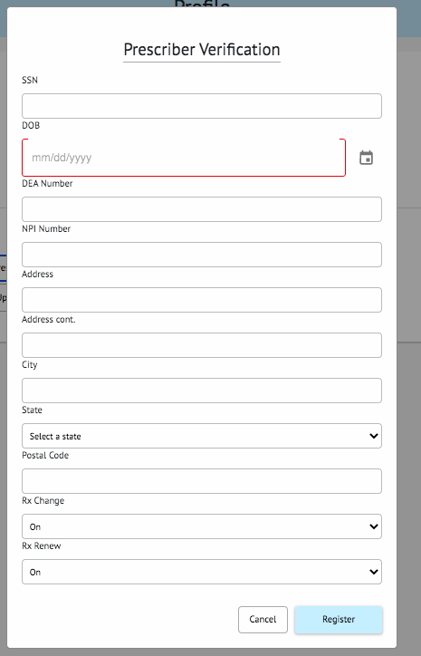

(Something the prescriber has)
- Now that you've successfully registered your credentials, you can Verify your Identity. Click on “Verify Your Identity” to begin the verification process. You will first need to submit your phone number to the third party and select what form of government ID that you are going to verify with:
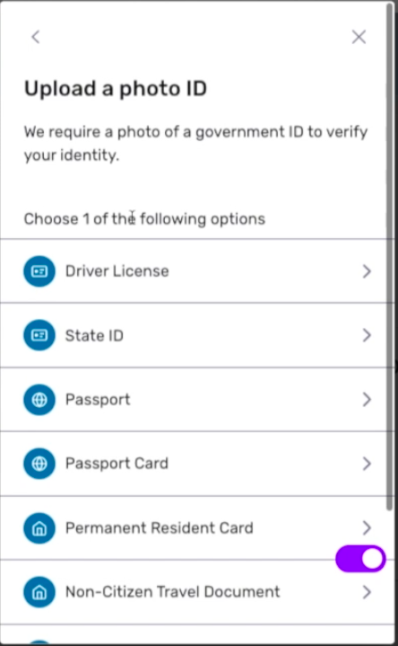

(Something the prescriber is)
- Once you upload the photo of your ID, you will then need to complete a live face scan so our software can perform a facial recognition test. By scanning the QR code presented on the screen or continuing on another device, the ID proofing service will ask to take a live face scan on you.

- Once you complete the face scan the software will verify you in a couple of minutes. Make sure to check your profile and see that you are now “verified” which means you can begin writing prescriptions and viewing patient profiles:
